
Our Week
(Things to remember)

Children should bring their reading folders
to school on Mondays and Fridays.

New spellings are usually given out on a Monday.
Spelling tests are on a Friday.

A water bottle must be brought to school. It will stay
in school and be washed daily.

PE is on a Thursday and Friday and children should
come to school wearing PE kit.

Homework is given on a Friday each week and is to
be returned by the following Friday.

This term our topic is Castles, Dragons and Knights.

This half term we will be:

- Reading ‘Puss in Boots’ and other traditional tales.
- Writing stories based on Dragons, Knights and Castles.
- Writing non-chronological reports about knights.
- We will be learning about the uses of everyday materials.
- Making a junk model castle. Please save your shoe boxes and kitchen roll tubes for our art projects.
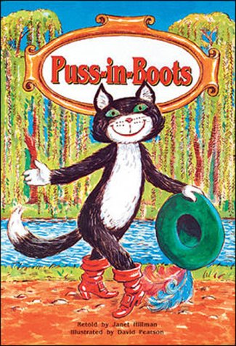

Next half term we will be:

- Reading myths and legends such as King Arthur, Robin Hood and St. George and the Dragon.
- We will be writing our own dragon poems.
- We will be studying the life cycle of a chicken and will have our own ‘living eggs’ in our classroom!
- Studying medieval history- the battle of Hastings and William the Conqueror.
- Visiting the Castle Keep and learning about the history of castles, how they were designed, built and invaded.

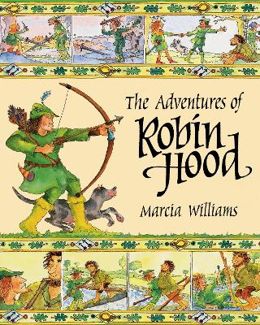


Some useful websites are:
- http://museums.ncl.ac.uk/keep/

- http://woodlands-junior.kent.sch.uk/Homework/castles/concentric.html

- http://www.kidsonthenet.org.uk/castle/

- http://www.bbc.co.uk/schools/ks2bitesize/science/materials/

- http://www.angelfire.com/dc/childsplay/castleunit.htm -extra activities you could do at home.

- http://www.printactivities.com/Theme-Printables/Dragon-Printables.html

Please feel free to email any member of
Y2 staff if you have any queries.

Miss Cliff
Mrs Mann
hannah.cliff@christchurch.newcastle.sch.uk
tanya.mann@christchurch.newcastle.sch.uk

