Extra Information:
Monday: Spellings given to learn.
P.E. kit to be brought to school.
Book bag returned with evidence of reading noted in reading records.
If you could either read with your child or question them about what they have read this would help greatly.
Wednesday: Homework must be
returned.
Thursday: Recorders.
Friday: Achievement Assembly.
Spelling test
Homework
P.E kit taken home.

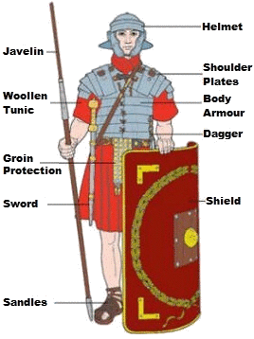
This term our project is Revolting Romans and Vicious Vikings

This term we will be:

- Reading the legends of Boudicca and Beowulf
- Looking at the Romans, Anglo Saxons and Vikings on a timeline
- Researching and finding out about life in Britain at this time
- Investigating Roman life
- Researching Roman gods
- Finding out how far the Romans had to march to get to England
- Making a Roman shield.
- Writing a recount to retell the events in the past.
- Creating an explanation leaflet of how Roman soldiers were a ‘fighting machine’.
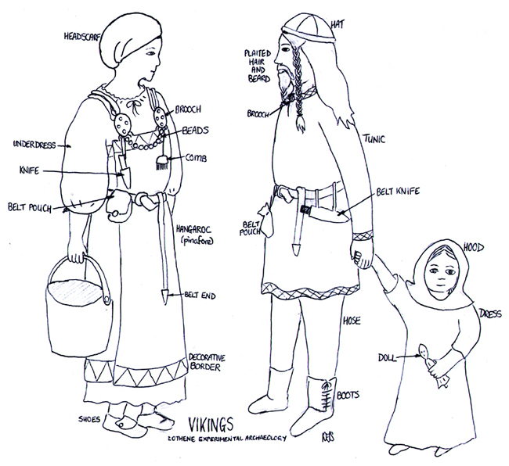

- Finding out about the Anglo – Saxons influence on Britain.
- Finding out how the Vikings invaded.
- Making a Viking long ship.
- Researching Viking life.
- Investigating Viking gods.

Maths – things your child should know:
- Know and recall 2, 3, 4, 5, 8 and 10 times table facts and corresponding division facts.
- Know division is the inverse of multiplication and use this to record related multiplication and division number sentences.

You can help by visiting the library to look at books about romans and Vikings. Children could bring in any artefacts or books that are linked to the topic.

Some useful websites are:

- http://www.bbc.co.uk/education/topics/zwmpfg8
- http://www.primaryhomeworkhelp.co.uk/Romans.html
- https://segedunumromanfort.org.uk/
- http://www.bbc.co.uk/education/topics/ztyr9j6
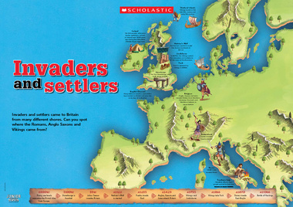
- http://www.bbc.co.uk/schools/primaryhistory/vikings/who_were_the_vikings/

